Newsletter
www.8parkroad.com February 2010

HAPPY NEW YEAR
&
Kung Hei Fatt Choy
Sun Tzon Lek kein

The Chinese New Year fell on February 3rd this year. People born in the Year of the Rabbit are articulate, talented, and ambitious. They are virtuous, reserved, and have excellent taste. Rabbit people are admired, trusted, and are often financially lucky. They are fond of gossip but are tactful and generally kind. Rabbit people seldom lose their temper. They are clever at business and being conscientious, never back out of a contract. They would make good gamblers for they have the uncanny gift of choosing the right thing. However, they seldom gamble, as they are conservative and wise. They are most compatible with those born in the years of the Sheep, Pig, and Dog.

Thank you to Michelle Ma for the Chinese New Year decorations
LOCATIONS OF EMERGENCY
BUTTONS & INTERCOMS
P10 Garage P9 GARAGE
Spot where only an intercom & camera is located. | Spot where only an intercom & Camera is located.
P10 Elevator Lobby | P9 Elevator Lobby
P10 Across from Stairwell by Spot #23 or on the other side of the pole is marked as Spot #51 | P9 Across from Stairwell by Spot #23
P10 Across from Stairwell by Spot #31 | Across from Spot #51
Where Only the Emergency Alarm is located | Where Only the Emergency Alarm is located
P10 Across from Spot 53 (Camera from spot 19 faces onto this) | P9 Across from Spot #53 (Camera from spot 19 faces onto this)
Where Alarm button & Intercom is located together | P9 by Spot #56 (5 feet way from emergency alarm)
P10 Across from Spot #4 | Where Alarm button & Intercom is located together
Where Fire Phones are located | P9 Across from Spot #4
P10 Outside Elevator Lobby beside pull station | P9 Across from stairwell by Spot #31
p8 garage
Spot where only an intercom & Camera is located.
P8 Elevator Lobby
P8 Across from Spot # 4
P8 Across from Spot # 15 or by Spot # 39
P8 Across from Spot # 23
Where Only the Emergency Alarm is Located
P8 Across From Spot # 12
P8 by Spot # 23
Where Fire Phones are located
P8 Outside Elevator Lobby
By Spot # 19 beside Exit Stairs

TOWN HALL MEETING
Arbitration Decision

We held a Town Hall Meeting Wednesday February 9 at 7:00 p.m. to announce the decision of the arbitration.
Mr. Caplan, the Arbitrator has “split the costs in half”. Following a detailed analysis of the evidence, expert reports, and case law, he has determined at paragraph 100, page 36 of the report, that half of the total repair costs of are to be treated as non-capital costs, with the remainder to be treated as capital costs. As a result of this finding, TSCC 1525 is liable for its contribution to capital costs calculated in accordance with the formula set out at Article 9.09(b) of the Reciprocal Agreement. This formula requires a calculation of the “Easement Area”, which is defined in the agreement as being those driveways allocated for use by the Condo, ramps, entrances, and exits located in the above surface Larco Parking Area. We have agreed with Larco that it will be necessary to calculate the Easement Area. To date, Larco has provided their calculations; we have provided ours and they are being considered by Larco.

Once we have agreed on the calculation of the Easement Area, the capital cost relating to the Easement Area is then multiplied by approximately 26.8%.This represents the proportion of parking stalls in the condo’s parking area compared to the total of the parking stalls in the condominium’s parking area plus the number of parking stalls in the above surface Larco Parking Area. Final calculations are expected in approx. 4 weeks.

Director & Officer CHANGES
As some residents are aware Beverly Snodgrass has sold her suite and has resigned from the Board of Directors. We wish to thank Beverly for her input over the years and wish her luck in her new home.

With a position being open the Board of Directors has appointed William Shawn to take over Beverly’s position until the next AGM in October/November 2011.

Website:

The Board and Management are in the process of getting the 8 Park Road website up and running. We hope to have this completed during the month of July. Please keep your eyes and ears open for this announcement. Our web address is www.8parkroad.ca

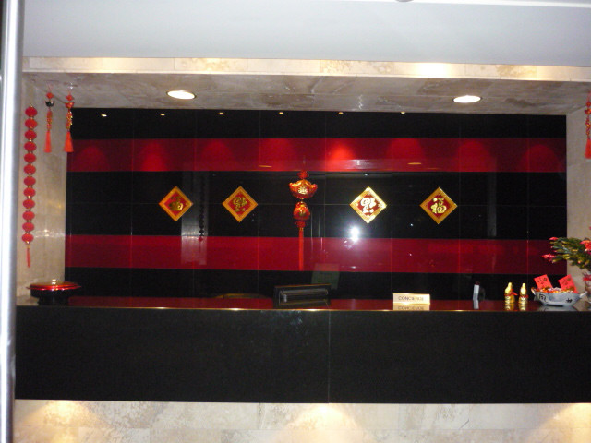
Parking Garage
For residents using the parking garage we would like to point out some safety items in the garage that you may not be aware of in case of an emergency.
Throughout the garage there are intercoms and emergency push buttons in case you run into any problems, whether it is a health problem or worse case scenario you feel threatened.

These are located throughout the garage on each level. In some areas they just have the emergency push button which will sound an alarm (below). The one above also has an intercom which goes directly to the concierge’s desk.

There are also camera’s located through out the garage. Also through out the garage there are pull stations for the fire alarm and a telephone located next to it.
The Board of Directors and Management recommend that you familiarize yourself where these areas are in case you run into an emergency situation.

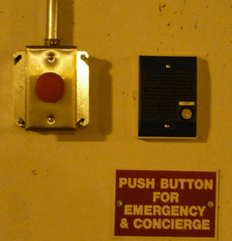

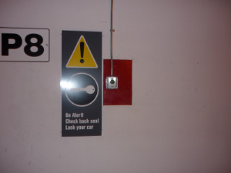

Parking Garage Remotes

Just a reminder to residents with parking garage remotes, it is up to each individual with parking garage remote to ensure that the battery is replaced periodically. If the batteries are not replaced, you will start to encounter the gate arms will not open and you will have to pay to get out. If this occurs Carpark will not reimburse your payment.
Garbage Rooms

A number of residents are leaving garbage on the floor in the garbage rooms on each floor. It is up to each individual to ensure that the garbage is put down the chute and not left on the floor. All recyclables are to be brought down to the recycle room in the Skylobby and put in the correct bins. We have labeled each bin. To the new owners and/or residents we also have recycle bins there for clothes that are donated to Planet Aid. Clothes and large items should never be put down the garbage chutes. This can cause the chute to be blocked and could damage the compactor. If you have any questions on what may be done with any items, please contact the management office and/or call the concierge’s and we would be glad to assist you. Furniture is the responsibility of the owner/resident to have these items removed from site. The Corporation has no way of disposing of these items.

To Pet Owners In The Building
As per the rules and regulations:
No animal, livestock, reptile or fowl other than a domestic cat, dog, any small bird allowed at the discretion of the board (i.e. canary, budgie), guide-dog as defined in the Blind Persons’ Rights Act, R.S.O. 1990, hearing ear dog necessary to accommodate a hearing disability or tropical fish

.

shall be kept within the unit or allowed upon the Common Elements, (including those parts thereof of which the owner has the exclusive use) and no cat or dog shall be permitted to run free upon the Common Elements. All dogs and cats shall be controlled with a leash, no longer than 5 feet, or carried while passing through the Common Elements. Notwithstanding the foregoing, the Board of Directors, in their absolute discretion, may determine whether an owner’s pet is considered a nuisance or an interference with rights of other owners to quiet enjoyment of their units and the Common Elements. An owner shall within two weeks of receipt of a written notice from the Board of Directors or the Property Manager on behalf of the Board of Directors, requesting the removal of a pet, so considered a nuisance or interference, permanently remove the same from the Building.

Each pet owner must ensure that any defecation by such pet is cleaned up immediately by the pet owner, so that the Common Elements are neat and clean at all times. This includes the front entrance and planters on the street level in front of the Building. Should the pet owner fail to clean up after his pet as aforesaid, the pet may be deemed to be a nuisance, and if determined as such, the owner of said pet shall, within two (2) weeks, of receipt of written notice from the Board of Directors or the Property Manager requesting removal of such pet, permanently remove such pet from the Building.
The reference to dogs as permitted in Section 6 of these Rules does not include dogs over 22.68kg (50 pounds) of weight.

A maximum of two dogs, two cats or one dog and one cat is permitted per unit in the Building.

All pets must be registered with the Property Manager.

Pets can not be walked to be relieved in any areas of the Common Elements including on the 15th floor terrace. Pets shall not relieve themselves in any part of the Common Elements. The owners of pets may receive a removal notice upon violation of these Rules.

Update from Green Committee
By Virginia Lawrence

Earth Hour is Saturday, March 26th this year and we look forward to seeing all of you turning your power off between 8:30 p.m. and 9:30 p.m. and joining us in the party room for refreshments, discussion, prizes and fun. Since many committee members will be out of the country, volunteers for this event will be greatly appreciated. Please contact Bob Stover directly at 416 927 1946 or leave your name at the concierge’s desk

In our bicycle survey, 15 people expressed an interest; of these many said they could pay only $20.00/month or less. We have forwarded our request to the board of directors.

After proposal of replacement of the sodium mercury lights in our parking garage the Board is now studying the pros and cons as well as cost effectiveness of changing to fluorescent, induction or metal halide lighting.

We are seeing more and more extreme weather events (floods, heavy snowstorms, fires, cyclones etc.) all over the world, not just where polar bears and penguins live but in places like Australia and the U.S. northeast. Environmental degradation caused by human activities is a major contributing factor. Please conserve water, gas and electricity by washing only full loads, lowering the thermostat and turning off lights etc. You have done a fantastic job in bringing paper products, cans & bottles to the recycling room. It is now possible to recycle and/or dispose safely electronic devices, batteries, light bulbs and computer ink cartridges, so bring those too.
We look forward to working together with the Building Improvement Committee on a major renovation on our terrace in the spring or summer.

Building Improvement Committee
By John Stuart

For the owners who do not live in the building the building improvement committee has started some of the improvements to the street lobby. The desk has been removed and replaced with a mosaic tile wall, and planters have been installed in front of the wall. We have also recovered the bench in the street lobby. All of this at no cost to the residents since the money was part of the settlement with Brookfield for access to the stairwell back in 2008.

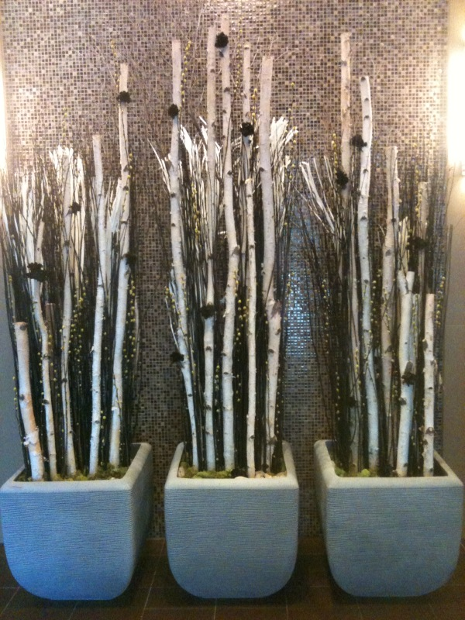

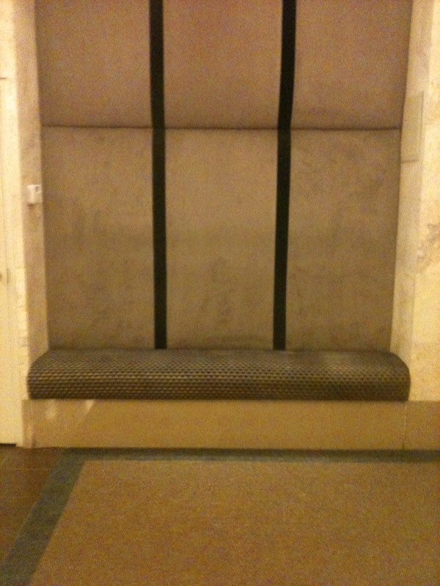

www.8parkroad.com
Email Property Manager: 8parkroad.pm@delcondo.com
Email Directors: 8parkroadBoard@8ParkRoad.com
Phone Property Manager: (416) 944-8908
Phone Concierge: (416) 944-9560
Fax: (416) 944-9435

